OEM-quality calipers and motors: Continental simplifies repair of electric parking brakes for workshops
- Same as the original: Servomotors and brake calipers from the original manufacturer
- Products for many high-volume VW, Audi, Skoda and Seat models
- Brake calipers also available in matt black, tornado red and ultramarine blue
Schwalbach, Germany, July 9, 2020. The technology company Continental is expanding its product range for repairs of electric parking brakes in the independent aftermarket. Starting now, workshops and dealers can order both motors and preassembled caliper-motor units as original ATE parts. “Our aim is to offer the aftermarket as many spare parts as possible in OE quality,” says Peter Wagner, head of OE & Aftermarket Services at Continental. “Independent workshops can now benefit from our OE expertise when repairing electronically controlled parking brake systems.” Workshops can obtain products for numerous high-volume models made by VW, Audi, Skoda and Seat, including VW Golf VII Arteon, Audi A3, Skoda Superb and Seat Leon. Continental will soon also offer spare parts for electric parking brakes in the vehicles of many other European manufacturers.
An economical alternative: motor in OEM quality
The servomotor in a brake must do hard work, so it can fail before the brake caliper does. In such cases Continental offers workshops an alternative that is appropriate to the vehicle’s current value: a separate servomotor in OEM quality. The entire brake caliper unit doesn’t have to be replaced, just the motor. This saves time and money. The defective motor is removed, a new one is installed, and the motor is then relearned to the vehicle by a diagnostic device like the Autodiagnos Check. The car is ready to go again.
Brake caliper unit simplifies replacement
If, on the other hand, the caliper in an electronic parking brake is faulty, it is usually necessary to replace the motor along with it. “In a vehicle with a damaged caliper, the motor tries to compensate and raises its output to extreme levels. Then it’s only a matter of time before it fails,” explains Henrik Ohlhaver, Product Manager at Continental. “Here a new brake caliper unit is the simplest solution because our new brake caliper unit is delivered preassembled.”
Drivers who opted for colored brake calipers when they bought a new car won’t have to do without them after a repair job. In addition to its standard product, Continental offers calipers in matt black, tornado red and ultramarine blue – just like the originals.
morecontinental.com: e-learning courses on electric parking brakes
Continental’s experts make sure that their knowledge is passed to the aftermarket. The Training Center offers numerous courses on basic electrical practice, the design of modern driver assistance systems, brake servicing and brake diagnostics. In addition, Continental’s e-learning program includes an object-based training course on electric parking brakes. The Knowledge Center also provides video tutorials on brakes. Anyone who is interested can download the training program at morecontinental.com, find out where the courses take place and book them.

Continental develops pioneering technologies and services for sustainable and connected mobility of people and their goods. Founded in 1871, the technology company offers safe, efficient, intelligent and affordable solutions for vehicles, machines, traffic and transportation. In 2019, Continental generated sales of €44.5 billion and currently employs around 240,000 people in 59 countries and markets.
Drawing on more than 120 years of cooperation with vehicle manufacturers, Continental offers a broad range of spare parts in OEM quality for the aftermarket. Under brands like Continental, Uniroyal, Semperit, ATE, VDO and GALFER, the technology company manufactures tens of thousands of products, including tires, brakes, drive components and thermal management components. It also provides diagnostic solutions, tools and services for repair shops. Continental is one of the most important suppliers in the independent automotive aftermarket.
Press contact

Oliver Heil
Manager Media Relations
Commercial Vehicles & Services
Phone: +49 69 7603-9406
E-mail: oliver.heil@continental-corporation.com

Press portal: www.continental-press.com
Media center: www.continental.com/media-center

Pictures and captions
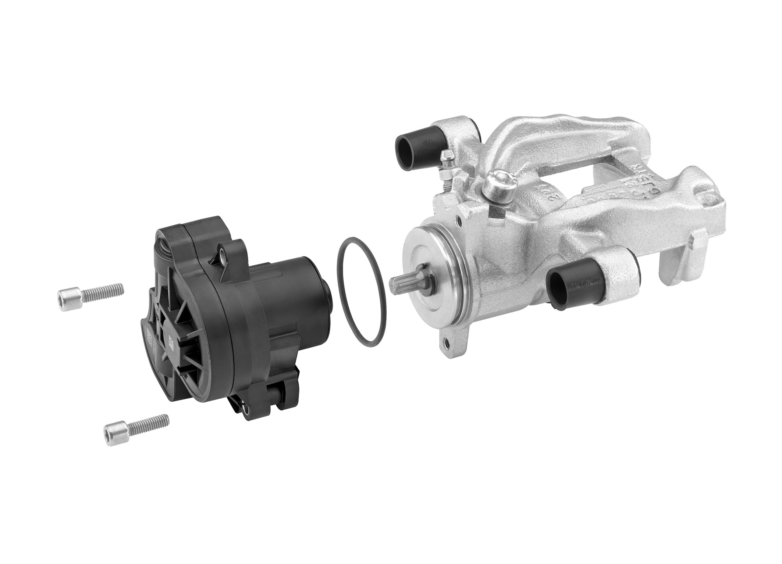Continental_PP_ATE_Motor_  Parking_Brake | Continental’s preassembled unit, consisting of a brake caliper and motor in OEM quality, simplifies repairs of electric parking brakes.
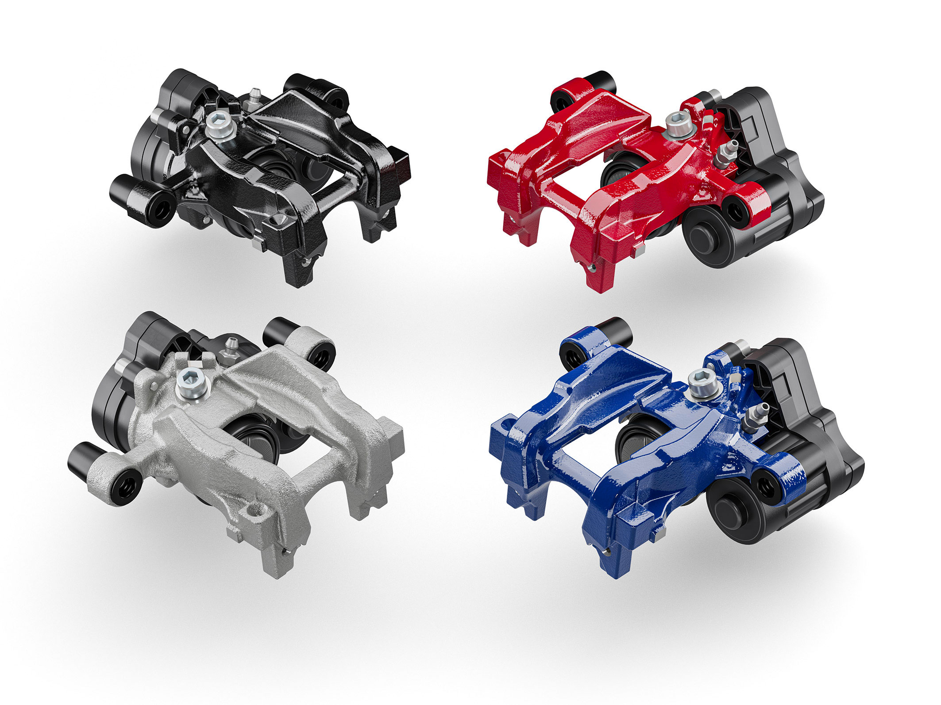Continental_PP_ATE_Continental_ brakecalipers | Matt black, tornado red and ultramarine blue: Continental’s brake calipers for the aftermarket also come in colors.
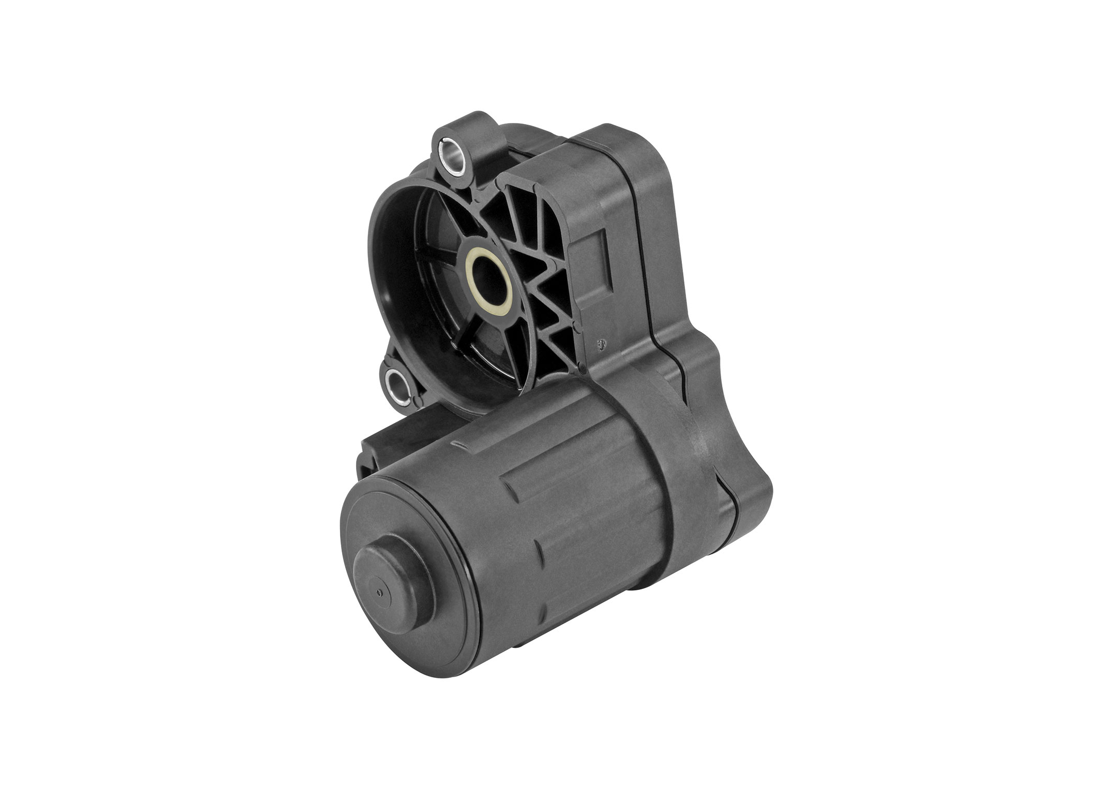Continental_PP_ATE_servomotors | Continental also offers separate servomotors for electric parking brakes.

